|  |
| --- |
| HRM Use-case Description |
| Manage Task |
| [Type the abstract of the document here. The abstract is typically a short summary of the contents of the document. Type the abstract of the document here. The abstract is typically a short summary of the contents of the document.] |

6/5/2012

Table of Contents

1 Use Case Description 1

1.1 Brief Description 1

1.2 Actors and UC Associations 2

2 Pre-conditions 2

3 Post-conditions 2

4 Flow of Events 2

4.1 Basic flow – View information 2

4.1.1 Flow starts: 2

4.2 Alternative Flow 1 – Add new information 3

4.3 Alternative Flow 2 – Edit information 3

The flow starts: 3

4.4 Alternative Flow 3 – Delete information 3

The flow starts: 3

4.5 Alternative Flow 4 – Print data 4

The flow starts: 4

5 Exception Flow 4

5.1 Exception Flow 1 – Add, Edit information 4

5.2 Exception Flow 2– Disconnection database 4

6 Activities Diagram 5

7 Business Rules 6

8 Special Requirements 6

# Use Case Description

## Brief Description

This use case allows user to Manage Task.

The following flows are described in this document:

* View information
  + Search information
  + Sort information
  + Filter information
* Add new information
* Edit information
* Delete information
* Print data

## Actors and UC Associations

**Actors:**

* Human Resource Planning and Managing Department members

**Use Case Associations:** depend on Manage Detail Information (If Manage Detail Information doesn’t have info => don’t use function in this use-case)

# Pre-conditions

1. User must log into HRM system
2. User has access Manage Task tab.

# Post-conditions

The information is viewed or updated.

# Flow of Events

## Basic flow – View information

### 4.1.1 Flow starts:

1. User is in a personal information management page and chooses menu “Position management”.
2. The system displays a page as described in GUI – Manage Task Management, with all personal information had been stored in HRM system before.

The flow ends.

4.1.2 Search information

1. User inputs object that needs to search in a text field

2. User chooses “Search” button

3. The system handles and displays the information that user needs

The flow ends.

4.1.3 Sort information

1. User chooses object in a list to sort

2. The system handles and displays the information that user needs

The flow ends.

4.1.4 Filter information

1. User chooses object in a list to filter

2. The system handle and displays the information that user needs.

The flow ends.

## Alternative Flow 1 – Add new information

The flow starts:

1. User chooses menu “Manage Task”.
2. The system displays a tab as described in GUI – Manage Task.
3. Click button “add”
4. User input data
5. User can choose “OK” button or “Cancel” button.

* If user choose “OK” button, data will be saved.
* If user choose “Cancel” button, data won’t be saved.

The flow ends.

## Alternative Flow 2 – Edit information

### The flow starts:

1. User chooses menu “Manage Task”.
2. The system displays a tab as described in GUI – Manage Task.
3. Choose information need edit
4. Click button “edit”
5. User can choose “OK” button or “Cancel” button.

* If user choose “OK” button, data will be saved.
* If user choose “Cancel” button, data won’t be saved.

The flow ends.

## Alternative Flow 3 – Delete information

### The flow starts:

1. User chooses menu “Manage Task”.
2. The system displays a tab as described in GUI – Manage Task.
3. Choose information need delete
4. Choose delete this information
5. User can choose “OK” button or “Cancel” button.

* If user choose “OK” button, data will be saved.
* If user choose “Cancel” button, data won’t be saved.

The flow ends.

## Alternative Flow 4 – Print data

### The flow starts:

1. User chooses menu “Manage Task”.
2. The system displays a tab as described in GUI – Manage Task.
3. Choose “print” button

The flow ends.

# Exception Flow

## Exception Flow 1 – Add, Edit information

1. At step 3 of Alternative flows, the user chooses “Cancel” button
2. The system displays a message “Do you really close it”
3. The actor acknowledges message
4. The system closes the message, doesn’t save data and back to personal management page

The flow ends

## Exception Flow 2– Disconnection database

1. At step 3 of Alternative flows, HRM system disconnects database
2. The system displays a message “HRM disconnect”
3. The actor acknowledges message
4. The system closes the message, back to log in page.

The flow ends

# Activities Diagram

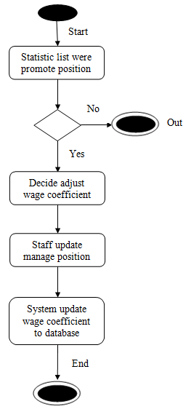

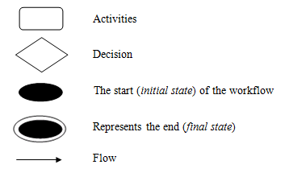

# Business Rules

# Special Requirements

Use case can satisfy security and performance.